ASSIGNMENT 9

AIM:

To design a differential cascade amplifier
CIRCUIT:

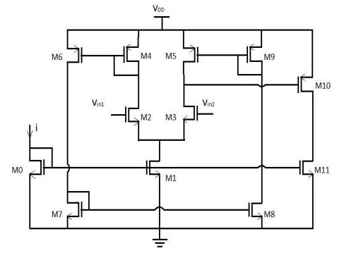

OBSERVATIONS:

The differential cascade amplifier works as expected.

